Comp 2406 – Assignment 3

Presented by Oscar Castelblanco. Id 101093569

**Developed on:**

* Windows 8 – 64 bits
* Browser: Chrome

**To run:**

* Unzip content into a folder
* Open a command window on the given folder
* Execute: *npm install*
* Execute: *node server.js*
* Open a chrome window on either:  
  *localhost:3000  
  http://localhost:3000/recipes  
  http://localhost:3000/start?ingredients=Cheese*
* On the web page a text field with a submit button will be shown. Write the ingredient that has to be searched for and hit the submit button or the enter key  
  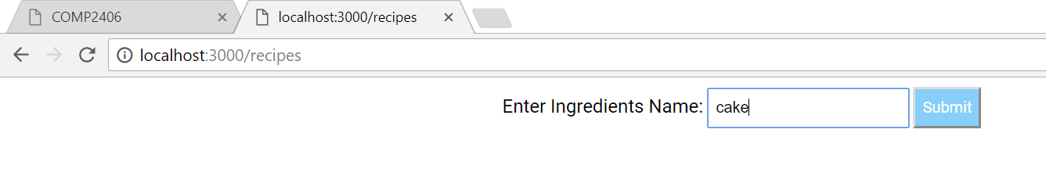

**Web page preview:**

